Apartment Tour Game Document

Input: A 12-character string, eg: “ctkpqnszftyu”

Video should be played on a Web Browser.

Total 3 tours of the apartment, one after the other.

***1st Tour***

Camera starts with a decent pace and visits all the 12 spots in the apartment. When it reaches a predefined spot, say mailbox, the navigation stops there for 5 seconds and an arrow appears on top of mailbox to indicate this location is of interest to the user. After 5 sec, the camera starts to move to next spot and the same action is repeated again.

Once all the spots are visited, 1st tour is concluded and now starts the 2nd tour.

***2nd Tour***

Camera starts from the same place it started in 1st tour and visits all the places in the same order. When the camera visits a place, it stops there for 5 seconds and instead of an arrow appearing, an object is already present above that location. The object that has to appear at a location number x is determined by the character at position x in the input string. For example, if we are at 3rd location, say refrigerator, then an object starting with k (k is at 3rd position in the input string) is selected from the inventory (say Kite) and is displayed above the refrigerator. When the camera stops at the refrigerator, the object (kite) which was already above the refrigerator flows in the center of screen and is enlarged and the name of object (“Kite”) is displayed below the object. The object is displayed for 5 seconds after which the navigation moves to next location. After all places are visited, 3rd tour starts.

***3rd Tour***

Exactly same as 2nd Tour

**Additional functionality**

**1.** Hit the spacebar key to pause/play the video

**2.** After 3 locations are visited, the video pauses and a pop up box appears where user is asked to type the 1st character of last 3 seen objects. For example, for last 3 locations the objects shown was “Kite”, “Dog” and “Mango”, then user has to type “kdm”. If the input is right (ignore case), display message “Correct” else display message “wrong” and then start with the rest of the tour. This should happen only in 2nd and 3rd tour. Irrespective of right or wrong attempt, the tour should move forward.

**3.** After the end of 3rd tour, display a popup and ask user to enter the entire input string. Display “correct” or “wrong” message and then finish the video.

**12 Predefined Locations**

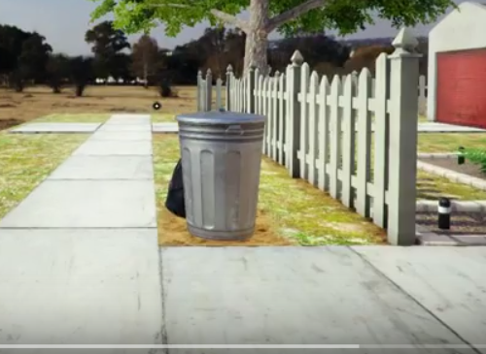

Location Trash Bin

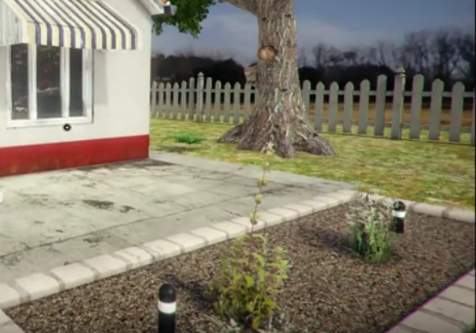

Location Outside Lawn at center of both bulbs

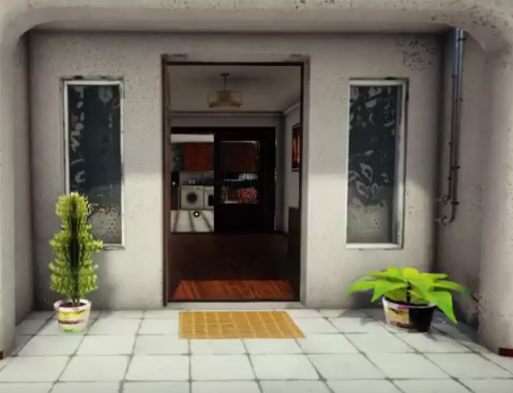

Location Entrance Door on top of Mat

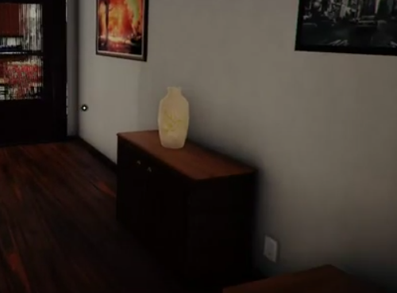

Location On top of the table, next to vase

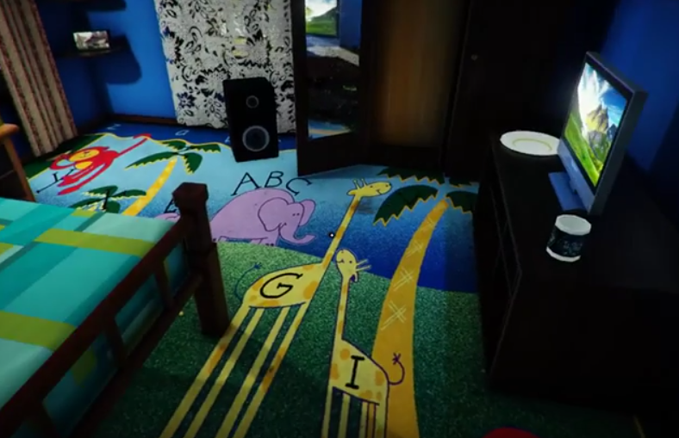

Location Child's bedroom on top of Bed

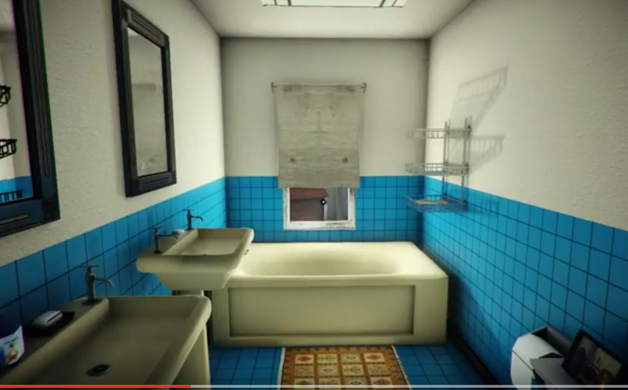

Location Bathroom, on top of the Bath tub

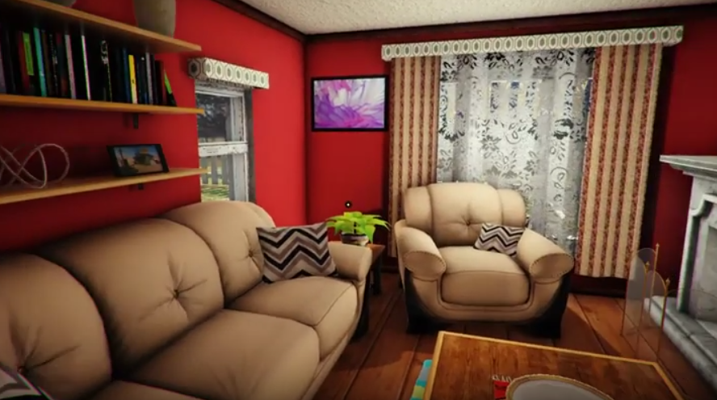

Location Living Room, on top of Sofa

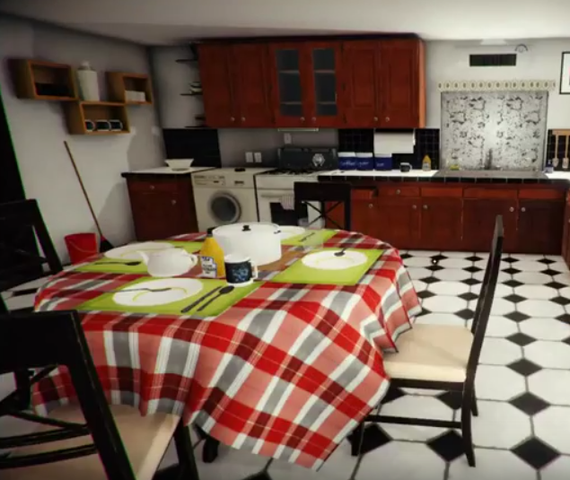

Location On top of Dining Table

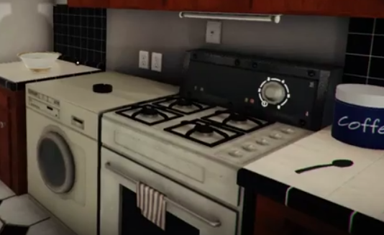

Location On top of stove

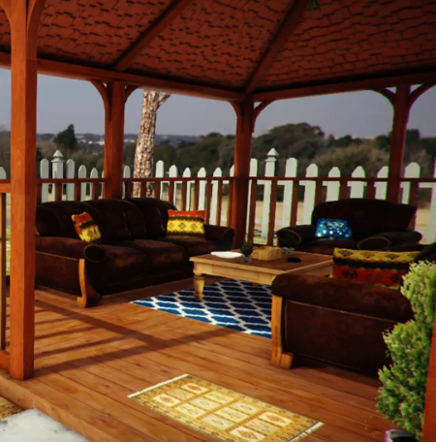

Location Outdoor Patio, on top of Table

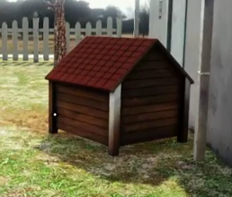

Location Top of Pet house.

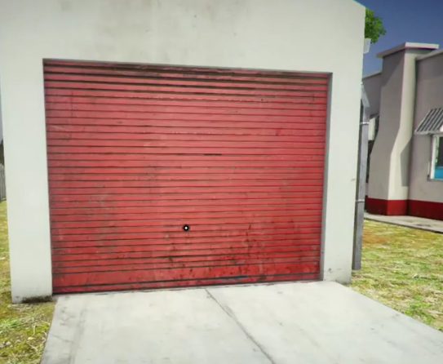

Location In the Garage

**Maximum Worst Case Runtime of entire video including all 3 scenes:** 15 minutes

Please keep the navigation as natural and smooth as possible.